***A Mini Project Synopsis on***

**Car Rental System**

**S.E. - I.T Engineering**

**Submitted By**

**VATSAL SINGH 19104006**

**SHUBHANGI TRIPATHI 18104067**

**PUSHKAR TELAVANE 19104011**

**Under The Guidance Of**

**PROF. ANAGHA AHER**



**DEPARTMENT OF INFORMATION TECHNOLOGY**

A. P. SHAH INSTITUTE OF TECHNOLOGY

G.B. Road, Kasarvadavali, Thane (W), Mumbai-400615

UNIVERSITY OF MUMBAI

**Academic year: 2020-21**

**CERTIFICATE**

This to certify that the Mini Project report **CAR RENTAL SYSTEM**

has been submitted by **VATSAL SINGH (19104006), SHUBHANGI TRIPATHI (18104067), PUSHKAR TELAVANE (19104011)** who are a Bonafide students of A. P. Shah Institute of Technology, Thane, Mumbai, as a partial fulfilment of the requirement for the degree in **Information Technology**, during the academic year **2021-2022** in the satisfactory manner as per the curriculum laid down

by University of Mumbai.

Prof. Anagha Aher

Guide

Prof. Kiran Deshpande Dr. Uttam D. Kolekar

Head Department of Information Technology Principal

External Examiner(s)

1.

2.

Place: A. P. Shah Institute of Technology, Thane.

Date:

**TABLE OF CONTENTS**

1. Introduction..........................................................................................................
   1. Purpose......................................................................................................
   2. Objectives....................................................................................................
   3. Scope..............................................................................................................
2. Problem Definition…………………...................................................................
3. Proposed System………......................................................................................
   1. Features and Functionality………………...……………………………….
4. Project Outcomes..................................................................................................
5. Software Requirements ........................................................................................
6. Project Design.......................................................................................................
7. Conclusion............................................................................................................

References

Acknowledgement

* **INTRODUCTION**

We developed this project to book a car on rent at the fare charges. In present system all booking work done manually and it takes very hard work to maintain the information of booking and cars. If you want to find which vehicle is available for booking then it takes a lot of time. It only makes the process more difficult and harder. This aim of the project is to automate the work performed in the car rental management system like generating daily bookings, records of car or cab available for booking, record of routes available, rental charges for cars for every rout, store record of the customer.

Car rental management system is a car booking software that provides a complete solution to all your day-to-day car booking office running needs. This system helps you to keep the information of Customer online. You can check your customer information any time by using this system. Cab rental management system is a unique and innovative product. Using this this you can also keep the information of number of bookings in current date or in last week or in last month. This helps you to track your business and you earning in particular month or in any year. Based on this information you can take decision regarding your business development.

Reason for the Project The advancement in Information Technology and internet penetration has greatly enhanced various business processes and communication between companies (services provider) and their customers of which car rental industry is not left out. This E-Car Rental System is developed to provide the following services:

Enhance Business Processes: To be able to use internet technology to project the rental company to the global world instead of limiting their services to their local domain alone, thus increase their return on investment (ROI). Online Vehicle Reservation: A tools through which customers can reserve available cars online prior to their expected pick-up date or time. Customer’s registration: A registration portal to hold customer’s details, monitor them transaction and used same to offer better and improve services to them. Group bookings: Allows the customer to book space for a group in the case of weddings or corporate meetings

* **Purpose:**

Our car rental management system provides a total solution to the field of auto rental industry. The idea behind the proposed website is to develop a system that allows customers to rent any vehicle as per their needs on the selected date for required time and in any of the selected cities.

This service will work 24x7. This system works online so allow anyone to book or rent a vehicle in a city without any time restriction. This system allows the customer to board the vehicle at his choice of location, pay for the rental online and could provide valuable feedback for improvement in services. With the help of a car rental management system, you can maximize the revenue by increasing your reach to customers. It helps him to take decision of hiring a car for their journey. By using it your customers will be able to make Car online reservations from your website, with just a few clicks. this system also keeps the information of cancellation and modification of booking in current month. This facility take the admin control over booking of the car as he can return the car. This system also helps the administrator to check the business of the company.

* **Objective**:

The main objective of the study is to design and implement a car rental system for an organization. The first objective is to reduce cost of the system by centralizing all the data which requires less staff under a more controlled environment. Specific objectives of the study are:

* To develop a simple and secure system that protects client’s information and confidential information of the organization.
* To design a user-friendly system that enables client check for availability of vehicle and book or reserve a vehicle online.
* To design a system that enables clients pay their car rent online or through cash.
* To develop a system that stores bookings and reservation information as well as payment history to help the organization keep track of transactions.
* Provide the customer a wallet facility where they can add cash through directed payment portal.
* To provide customer the facility of sorting the cars based on rating and distance travelled.
* User can also apply offer codes on their final amount.
* **Scope:**

This project traverses a lot of areas ranging from business concept to computing field, and required to perform several researches to be able to achieve the project objectives. The area covers include:

* Car rental industry: This includes study on how the car rental business is being done, process involved and opportunity that exist for improvement. PHP Technology used for the development of the application. General customers as well as the company’s staff will be able to use the system effectively. Web-platform means that the system will be available for access 24/7 except when there is a temporary server issue which is expected to be minimal.
* The fully functional Online Car Rental System will be delivered to the end user after the evaluation and the system testing. It functions as a system which storing, processing and handling customer information and the information of the most valuable assets which are the cars for the company.
* This online car rental solution is fully functional and flexible. It is very easy to use. This online car rental system helps in back-office administration by streamlining and standardizing the procedures. It saves a lot of time, money and labour. Eco-friendly: The monitoring of the vehicle activity and the overall business becomes easy and includes the least of paper work. The software acts as an office that is open 24/7. It increases the efficiency of the management at offering quality services to the customers. It provides custom features development and support with the software.
* **Problem Definition:**

Problem Identified:

To facilitate online Car Rental System. Design and implement a car renting website for customers where they can easily book cars for their long-distance traveling.

* Solution Proposed:

Develop a website where customers can book the cars for a long duration of time at affordable prices and convenience.

This Car Rental System project is designed to aid the car rental company to enable renting of cars through an online system. It helps the users to search for available cars view profile and book the cars for the time period. It has a user-friendly interface which helps the user to check for cars and rent them for the period specified. They could also make payment online. The rental cars shall be categorized into economy, premium etc. Based on the type of car required by the customer, the user shall be able to make bookings. The use of internet technology has made it easy for the customers to rent a car any time. This Car Rental System makes the bookings easy. It saves time and labour.

* **Proposed System:**

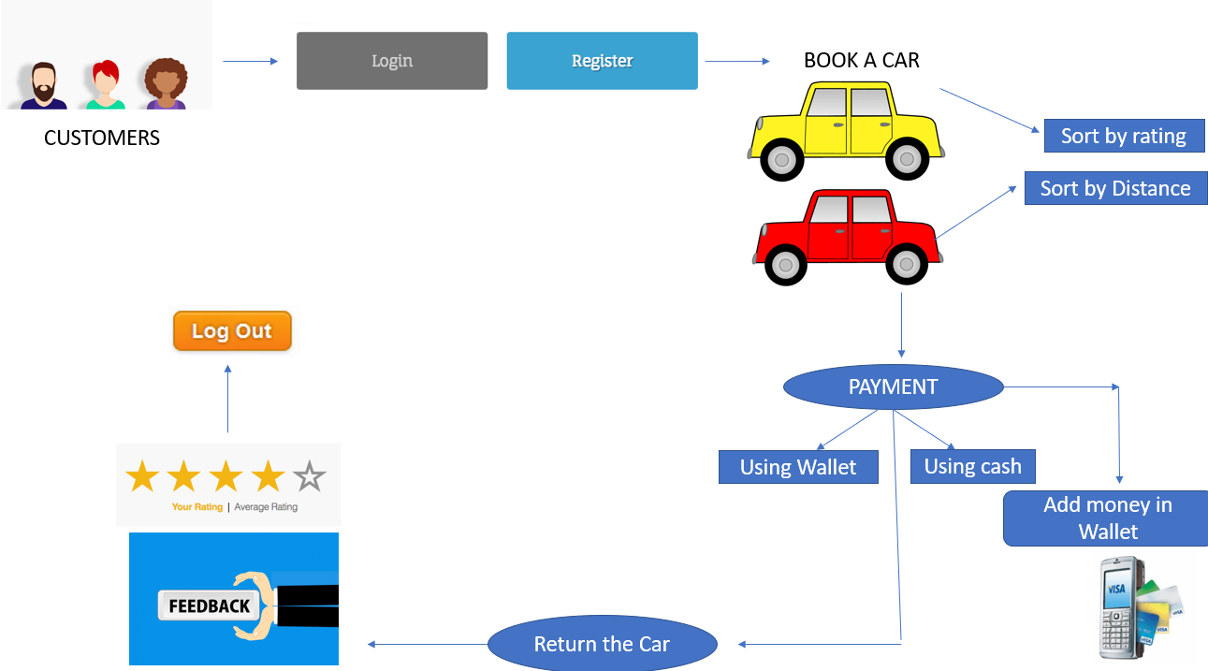

Fig 1- Shows the basic layout of whole system of online car rental

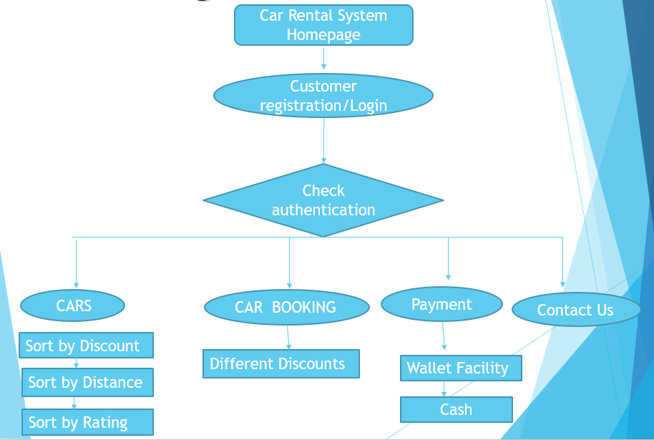

Fig 2- Block diagram of our system

* **Feature and Functionality:**

The features and functions provided in this project should satisfy all the user requirements and should be flexible enough so that future changes can be easily done based on the future upcoming requirements.

* Will give access to book cars from choices where user can sort them by rating and distance travelled.
* Registration: in this system user have to become a registered user to rent a car. User have to fill up his contact information like his name, address, mobile number in the registration form. After submitting the form, he gets username and password to login the system.
* Online Car Rental system are cheaper and also, they are not limited to any particular location. Customer can book a car at any time of day
* Payment gateway service that gives user facility to pay through wallet or through cash conveniently.
* Feedback mechanism for increasing service quality.
* Eco-friendly way of doing business.
* Cost saving due to discounts which user gets after applying valid discount codes active at that particular time.
* Global availability
* Benefits to organization- it will be able to gain benefits such as savings in operating cost, reduction in paperwork, better utilization of human resources and more presentable image increasing goodwill.
* Security of data and ensured data accuracy
* Minimal human inclusion with greater efficiency.
* **Project Outcome:**

This project guarantees the ease of booking car for your journey through an online mode. With all the features at their place, this project comes with following outcomes: -

* It is very easy to use. This online car rental system helps in back-office administration by streamlining and standardizing the procedures
* It saves a lot of time, money and labour. Eco-friendly: The monitoring of the vehicle activity and the overall business becomes easy and includes the least of paper work.
* The software acts as an office that is open 24/7. It increases the efficiency of the management at offering quality services to the customers.
* Customers will be able to log in and see through the variety of cars available.
* Customers can rate their trip and also give feedback for future betterment of services.
* Easy way to return the car and then pay through wallet or by cash.
* User will get different discount code, using which they can get off in their final amount.
* **Technological requirements:**

**HARDWARE REQUIREMENT**

**Client side:**

RAM 512 MB

Hard disk 10 GB

Processor 1.0 GHz

**Server Side:**

RAM 1 GB

Hard disk 20 GB

Processor 2.0 GHz

**Client side:**

Web Browser Internet Explorer 6 or any compatible browser

Operating System Windows or any equivalent OS

* **Project Design:**

The layout is given below. The final appearance of interface will look like this.



Fig 4- Shows the admin module. Here admin can add and delete books and modify any entry

Fig: The Homepage of our website having two options- login or register

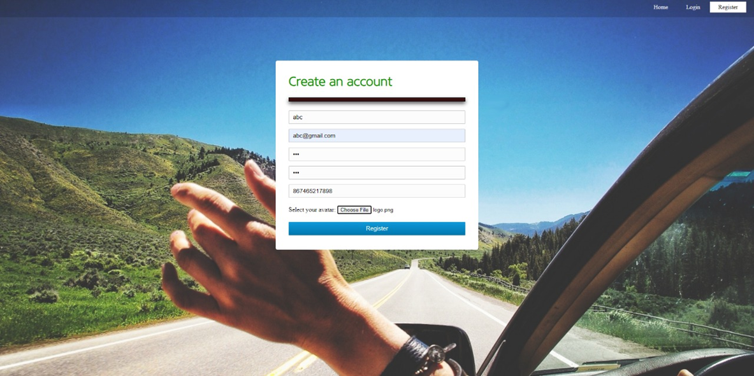

Fig: After clicking on registration user has to enter details

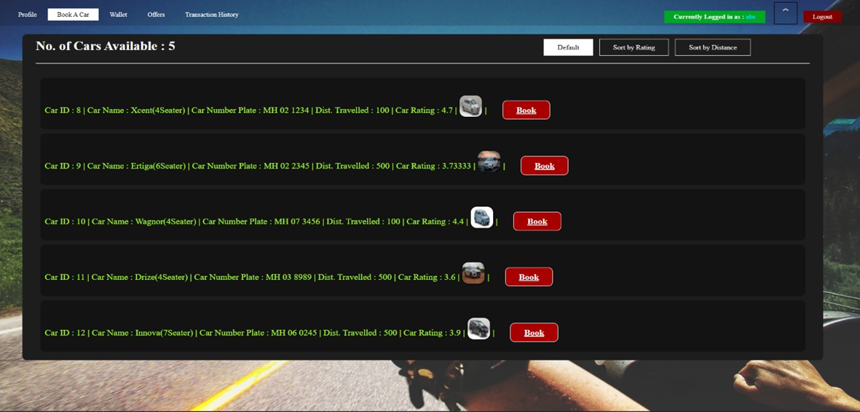

Fig: Book a Car option list of available cars, sort them by rating or distance

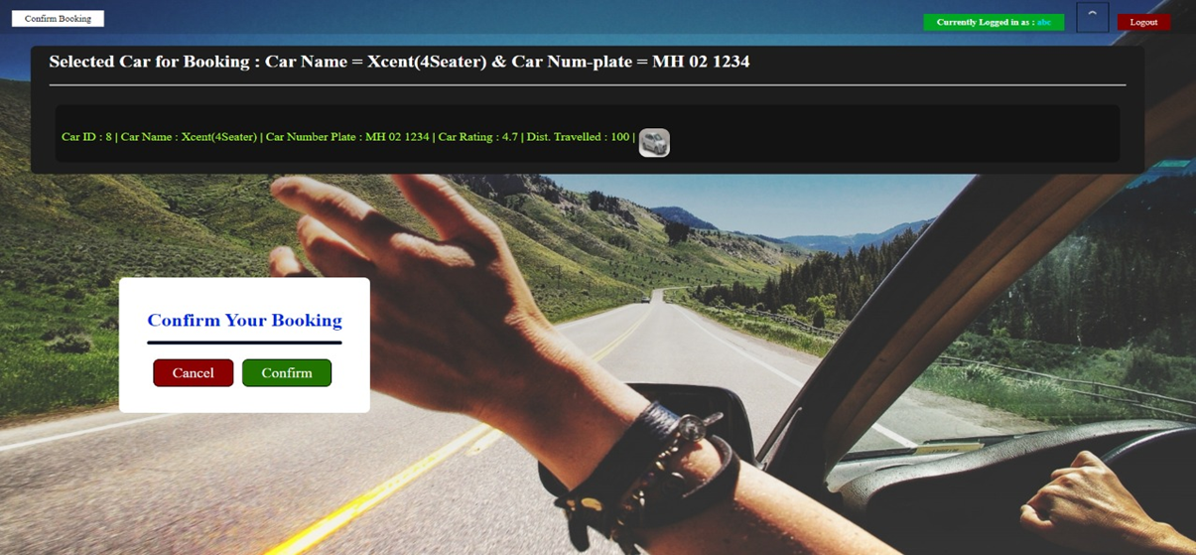

Fig: Confirm the Booking

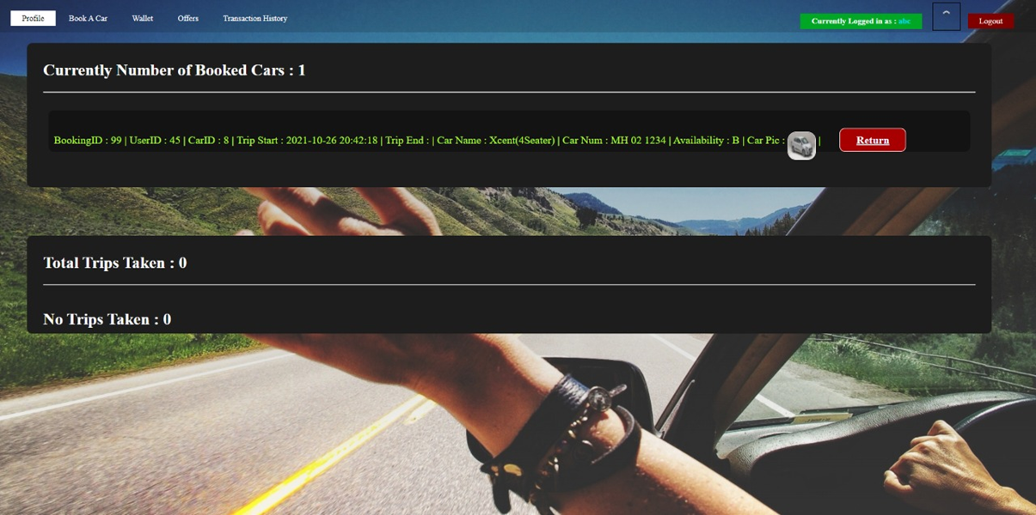

Fig: For returning the car, click on return button

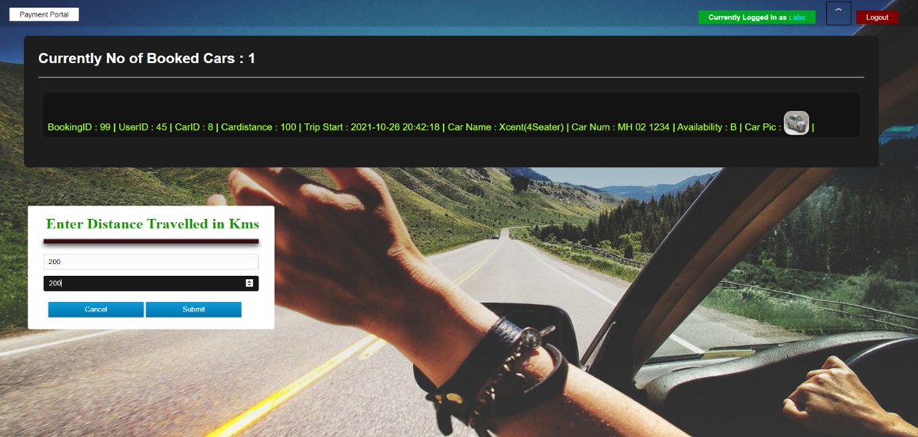

Fig: Enter the total distance travelled

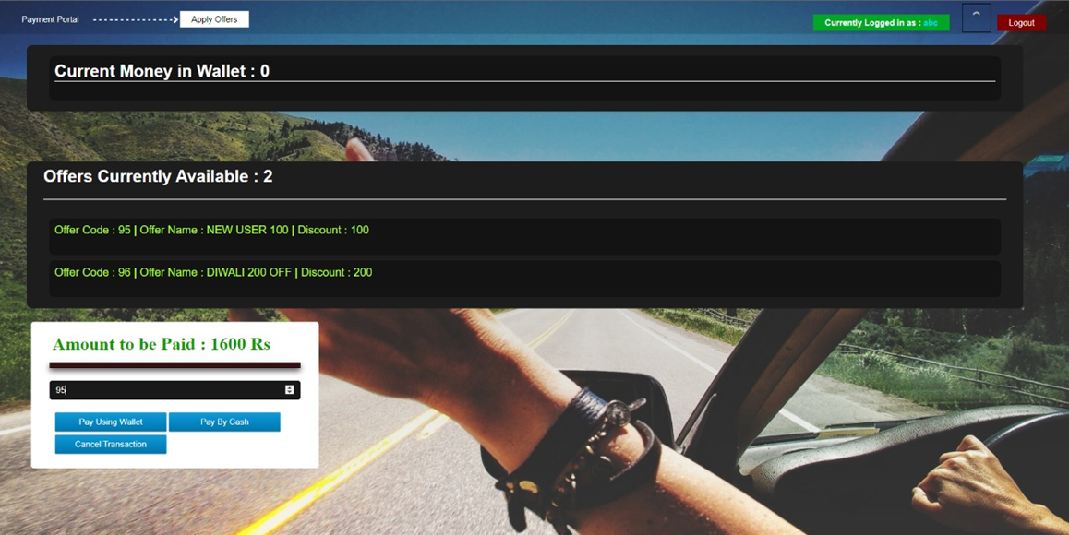

Fig: Total amount displayed. Put applied discounts and pay through wallet or by cash

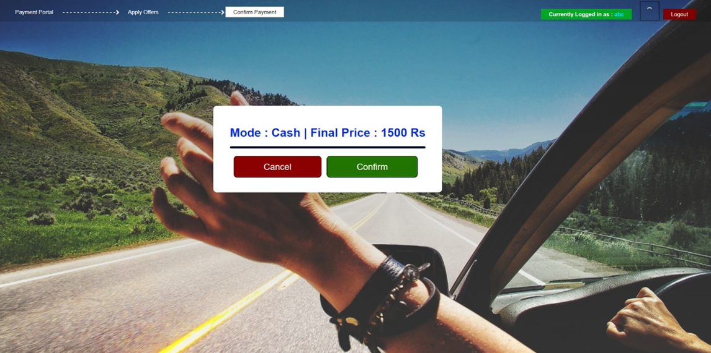

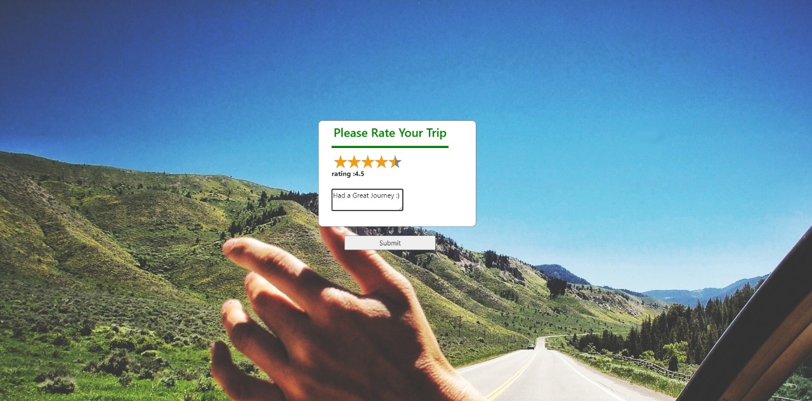

Fig: Rate your trip and also give feedback

* **Conclusion:**

In conclusion, the system will be able to serve as a web base application when it is finally developed, where these small upcoming companies can make use of it to publish their services in a wide range and also help the company to manage their service more effectively. On the other hand, it will enable customers to freely make their desire choice more freely and interactively. Car rental business has emerged with a new goody compared to the past experience where every activity concerning car rental business is limited to a physical location only. Even though the physical location has not been totally eradicated; the nature of functions and how these functions are achieved has been reshaped by the power of internet. Nowadays, customers can reserve cars online, rent car online, and have the car brought to their door step once the customer is a registered member or go to the office to pick the car. The web-based car rental system has offered an advantage to both customers as well as Car Rental Company to efficiently and effectively manage the business and satisfies customers need at the click of a button

* **References:**
* WIKIPEDIA- <https://en.wikipedia.org/wiki/Car_rental>
* YOUTUBE- <https://www.youtube.com/watch?v=QKRs3WS0dcg>

***ACKNOWLEDGEMENT***

This project would not have come to fruition without the invaluable help of our guide **Prof. Anagha Aher**

Expressing gratitude towards our **HOD, Prof. Kiran Deshpande**, and the Department of Information

Technology for providing us with the opportunity as well as the support required to pursue this project. We

would also like to thank our teacher **Prof. Anagha Aher** who gave us her valuable suggestions and ideas

when we needed them. We would also like to thank our peers for their helpful suggestions.